Packet Tracer – Connect to a Wireless Router

1. Topology

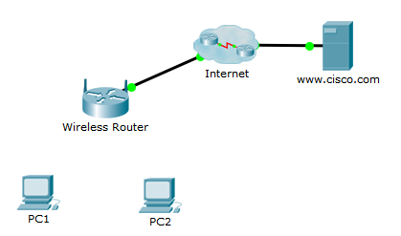

1. Objectives

* Connect two PCs to a wireless router using Ethernet cable
* Configure the PCs with appropriate IPv4 addressing
* Verify the PCs configuration inside the Command Prompt
* Verify connectivity to the Internet

1. Background / Scenario

For a PC to communicate on the local network and Internet, it must be connected to a network device. In this activity, you will connect two PCs to wireless router and verify the connection between the two PCs and to the Internet.

* + 1. Connect PCs to the Wireless Router.
       1. Connect **Connections > Copper Straight-Through** cable.
       2. With the cable selected, click **PC1 > FastEthernet0** and then **Wireless Router > Ethernet1**.
       3. Repeat Step1a and 1b for PC2 except choose another Ethernet interface on the Wireless Router.
    2. Assign the PCs an IPv4 address and default gateway.
       1. Click **PC1 > Desktop > IP Configuration**. Enter the following information:

IP Address: 192.168.10.2

Subnet Mask: 255.255.255.0

Default Gateway: 192.168.10.1

* + - 1. Close the PC1 window.
      2. Repeat Steps 2a and 2b for PC2 except use the IP address 192.168.10.3.
    1. Verify the IPv4 address configuration
       1. Click **PC1 > Desktop > Command Prompt**.
       2. At the prompt, type **ipconfig /all** to verify the configured IPv4 address and the default gateway from the previous step.
       3. Close the PC1 window.
       4. Repeat Steps 3a through 3c for PC2.
    2. Test connectivity between the two PCs and the Internet.
       1. Click **PC1 > Desktop > Command Prompt** and enter the command **ping 192.168.10.3** to test connectivity to PC2. The ping should be successful. If not, check your configurations from Step2.
       2. To test connectivity to the Internet, click **PC2 > Desktop > Web Browse**r. Type the address **www.cisco.com** and press Enter.

**Note:** The web page may take a several seconds to appear. To speed up the process, you can click **Fast Forward Time** in the main Packet Tracer window.

* + - 1. The web page should appear. If not, click **PC2 > Desktop > IP Configuration** and verify that the DNS Server address 209.165.200.10 was not accidentally modified or removed.